**Internship Project Report**

**On**

**Smart Agriculture system based on IoT**

Under Supervision Of

**Smart Bridge**

**Name:** Omkar Agrawal

**email-id**: omkar3654@gmail.com

**TABLE OF CONTENTS**

**Introduction** **3**

Overview 3

Purpose 3

**Literature Survey**

Existing Problem 4

Proposed System 4

**Theoretical Analysis**

Block Diagram

Software Designing

**Experimental Investigations**

**Flowchart**

**Result**

**Advantages and Disadvantages9**

Advantages9

Disadvantages**9**

**Applications ................................................................................................ 10**

**Conclusion**  **................................................................................................ 10**

**Future Scope ................................................................................................. 11**

**Bibliography ................................................................................................. 11**

Node-red Flow **.................................................................................................** 12

Source Code **.................................................................................................** 13

Node-red Source Code **......................................................................................** 13

# Introduction

## Overview

The goal of this project is to build a smart agriculture based on IOT, for active monitoring of agriculture even from remote places. This helps to get better yield from the crops, as well as reduce the damage caused to crops because of ineffective control of the environment in which crops grow.

The dashboard build in this project is based on the general requirements in the monitoring system. This can/shall be used by the farmers or an organisation for active and real time monitoring of the crops.

IBM Cloud Platform holds all the dashboard components. The platform is also used to collect real time data from the remote devices in the field and transmit it for monitoring and control purposes. It uses MQTT protocol for communicating with sensors and controllers, while using regular protocol for dashboard purposes.

## Purpose

The most important purpose of this project is to reduce the damage caused to crops, and provide a platform with most effective management systems for the farms. It is also used for analytics of the effect of the environment on the crops, for further micro scale changes required.

It is a real time dashboard, in the back it automatically collects the transmitted data from the sensors and the controllers, and displays it on the dashboard. This uses the helpful IBM Watson platform to automatically collect the data transmitted from the field. IBM Platform is also used to host Node-red on which the dashboard is based.

# Literature Survey

## Existing Problem

Existing solutions have a flaw which requires a substantial amount of human interaction in the form of manually monitoring the environment of the field. Human interaction is also required to turn on the lights manually, switch the motors, etc.

This becomes a major issue when the human interaction is not possible due to non-availability of people, or else some other conditions which would make it impossible to be manually regulated. In such situations, monitoring is also lost, since all the data collections are manually performed.

## Proposed System

The proposed solution consists of building a highly manageable portal, which will be used to monitor and control purposes.

The first problem of active monitoring is solved by using the Watson IoT platform. Sensors on the field communicate to transmit the data to Watson IoT platform.

Second problem of dynamic display of updated information is tackled using Node-red-App service of the Watson platform. Node-red is used to display the dashboard and communicate with the Watson IoT platform to update information on the dashboard.

# Theoretical Analysis

## Block Diagram

## Software Designing

The Project was kicked off using an Agile process known as Kanban. Each Task had to go through (not done, In progress, Review, Completed) columns. Using this software engineering technique, we were able to complete the project in a quick, efficient, and complete way. The steps performed were as follows:

* 1. Create Watson IoT Platform.
  2. Configure Watson IoT Platform.
  3. Create Watson Node-red App.
  4. Configure Node-red.
  5. Integrate Watson IoT platform and Node-red App.
  6. Build Node-RED flow to integrate data from Watson IoT.
  7. Deploy using a web dashboard.

# Experimental Investigations

After creating a use-case specific display and control for the dashboard, connecting it with Watson IoT platform to receive data and display it here are some of the experiment runs:

1. Dashboard:

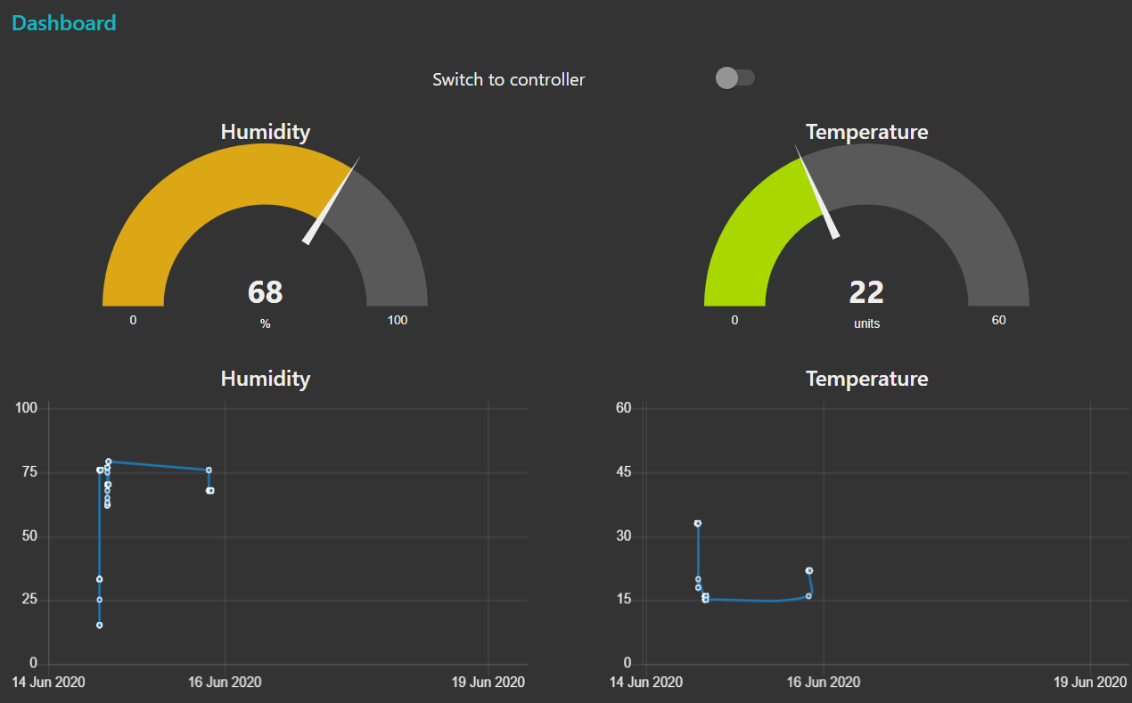

1. Controller: 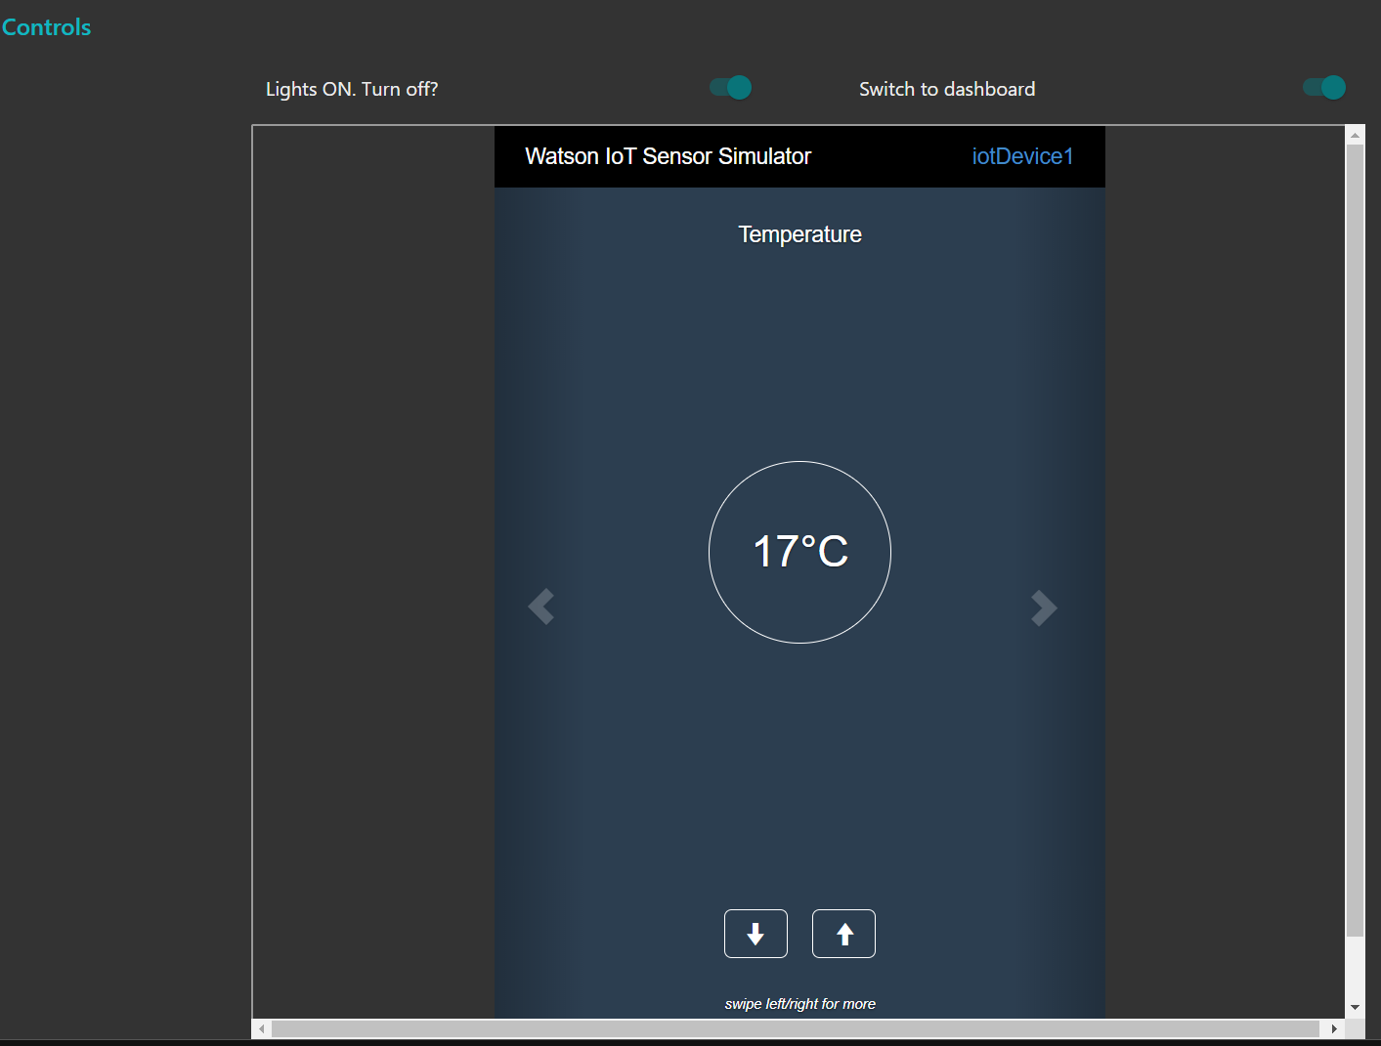
2. Controller start / end

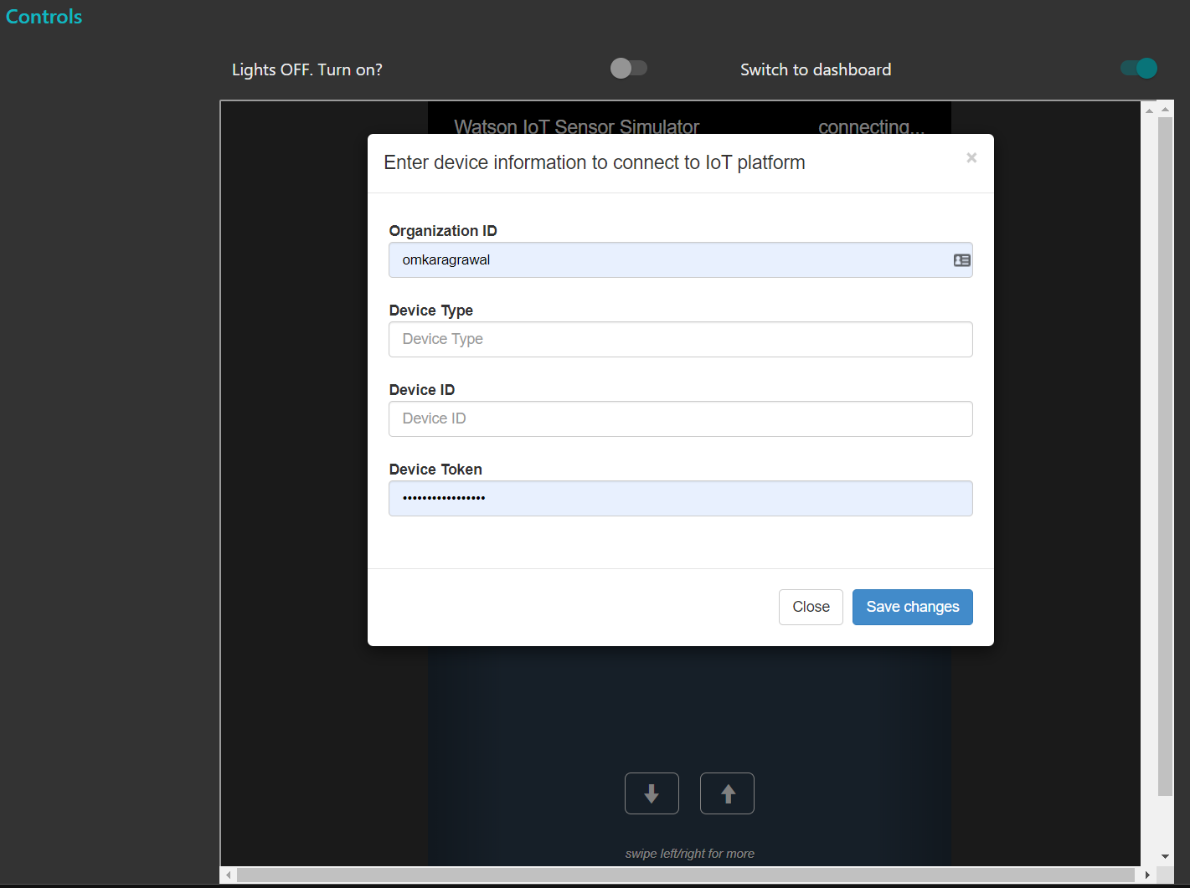

# Flowchart

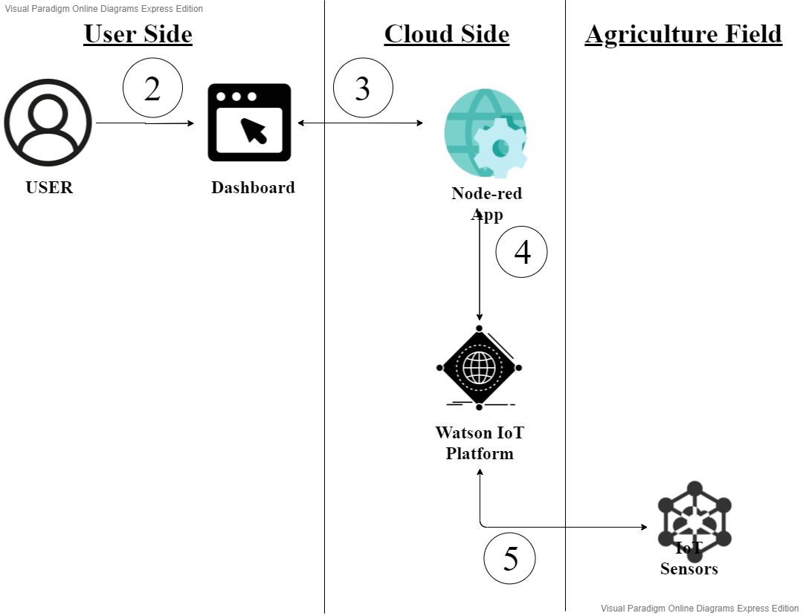

# Result

We have created an IoT enabled web based Smart Agriculture dashboard, which can be used to control and monitor the fields actively and remotely virtually from anywhere in the world.

# Advantages and Disadvantages

## Advantages

* It reduces human interaction based problems.
* It is less expensive in the long run.
* It is available 24/7.
* It provides real time sensor updates directly from the field without human intervention.
* Increases active control.
* It can be integrated with any sensors placed anywhere on any field.
* Rich analytics and better interaction
* Instantaneous response without the need for human response delays
* This dashboard can be used for any no. of the fields we require.

## Disadvantages

* Internationalization can be one of the major issues.
* It has a complex display and control behaviour for the uneducated.
* They may not be able to solve complex problems like moths, etc.
* It has a maintenance requirement on the field sensor’s side.

# Applications

This kind of dashboard can be used and deployed for multiple use cases. Anyplace where a controlled environment is required, this dashboard can be proven to be an effective solution.

Even though primarily developed for agricultural environment control and management. This dashboard can be deployed to any controlled environment. It helps to view and manage the environment variables with the help of sensors and controllers.

Some real-world use cases of Dashboard are:

* Workplaces: This dashboard can also be deployed for workplace, for optimum environment for work, but also saving a lot on inefficient electricity consumption.
* Theatres, malls, etc: This system is very effective for them, as it helps in providing optimum environments, but also can be customised to detect fire, etc emergency cases. While also saving on electricity.

# Conclusion

Hence, we were able to create a smart agriculture system based on IoT. Using great services provided by IBM on its cloud platform. IBM helps in getting real-time updates and back-end processing of the data, to provide users with a simple dashboard.

# Future Scope

1. Automatic control

Smart systems can be deployed based on this system without any major changes in its working. Custom rule based, or artificial intelligence based systems can be developed to further reduce human interaction and increase its effectiveness.

2. Multiple fields on a single dashboard:

Current system restrict a dashboard to control and display only one field at a time. It can be further improved to get the dashboard integrate multiple fields/places. This will help in reducing the cost to deploy multiple dashboards. It will also be better for users.

# Bibliography

1. [Creating an Iot device on IBM Iot Platform and connecting it.](https://thesmartbridge.com/documents/pdf/IoT-Device-Creation.pdf)
2. [Creating Node-red App on IBM Cloud.](https://nodered.org/docs/getting-started/windows#3-run-node-red)
3. [Connecting the IBM controller with Watson IoT platform.](https://watson-iot-sensor-simulator.mybluemix.net/)
4. [Creating a UI in Node-red.](https://smartinternz.com/assets/docs/Smart%20Home%20Automation%20using%20IBM%20cloud%20Services%20(1).pdf)
5. [Connecting using python.](https://github.com/rachuriharish23/ibmsubscribe)

## Node-red Flow

### 

### 

## 

Source Code

## Node-red Source Code